**Shell Script o display Good Morning, Good Afternoon, Good Evening According to system time**

**Example 1:**

**Step 1:** Open a greetings.sh file



Step 2: Running the Code for the greetings

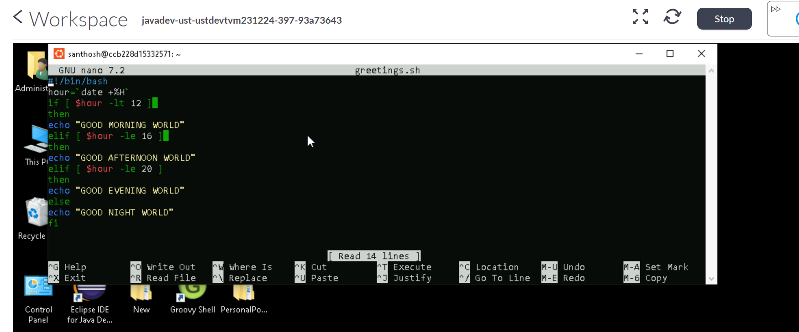

Step 3: Output

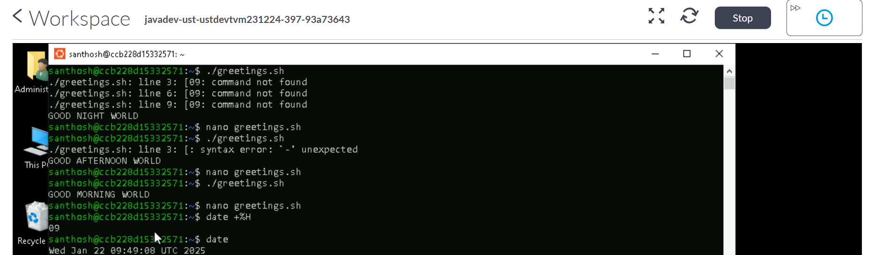

Example 2:

**Example 1:**

**Step 1:** Open a greetings.sh file



Step 2: Running the Code for the greetings

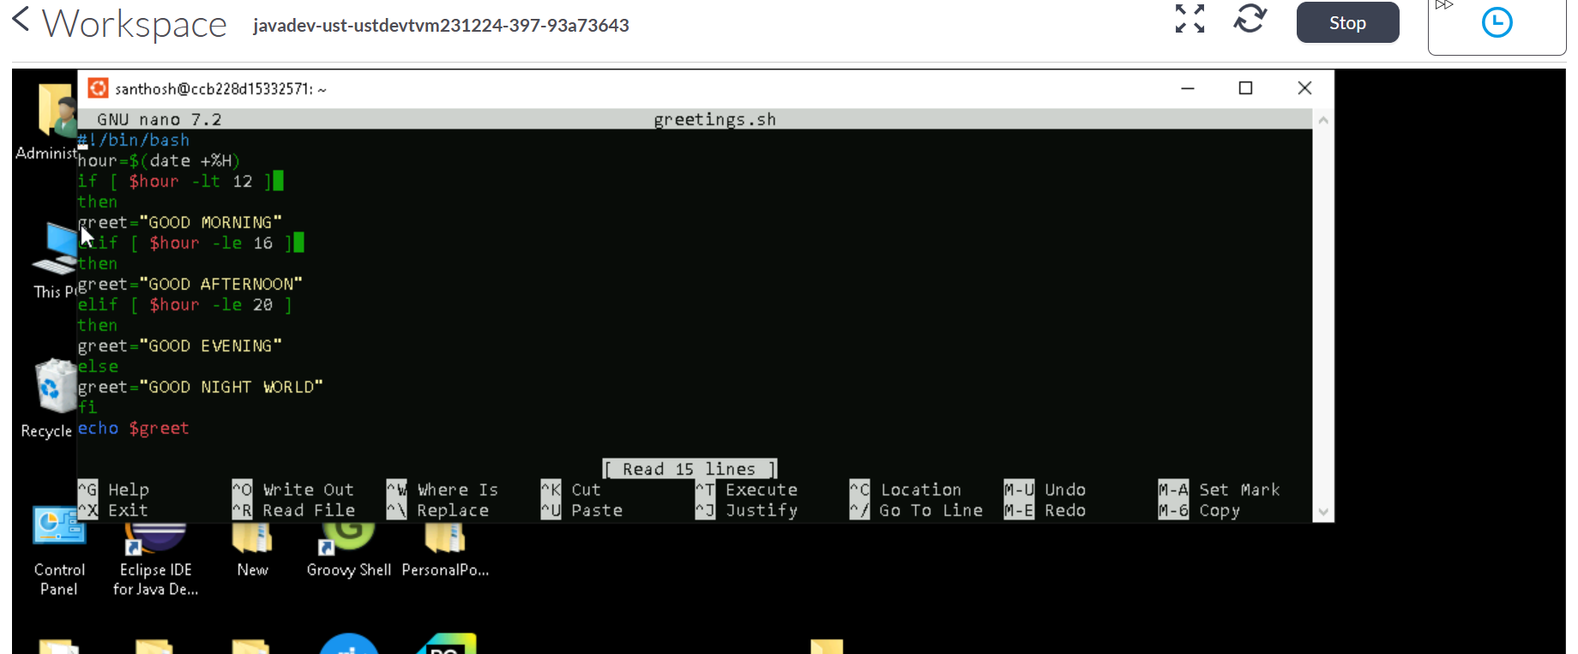

Step 3: Output

